**STUDENT DASHBOARD**

-**BANSARI PATEL**

**1.DESIGN:**

Figure 1 is the Login Page for the system and Figure 2 is the redirected page after login that is Enrollment for students’ page.

Figure 3 is for the Course creation for the Professor so that they can enter courses for provided semester and the other image is for faculty to view them the list of students that are enrolled in courses.

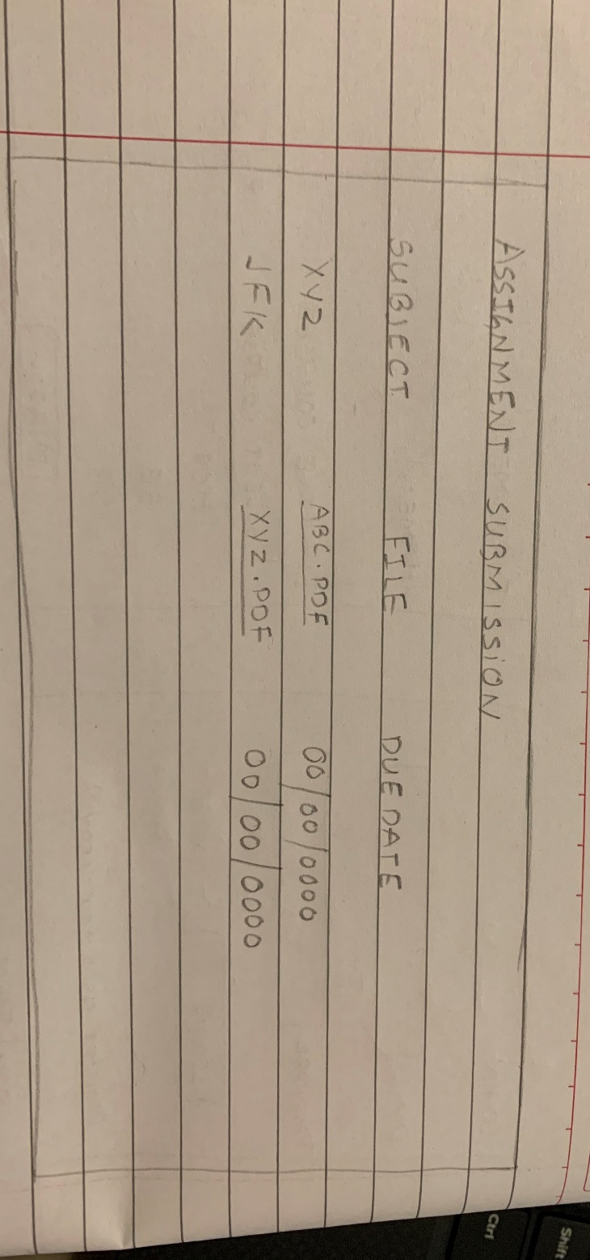

Figure 5 shows the assignment distribution page that will be available to the students.

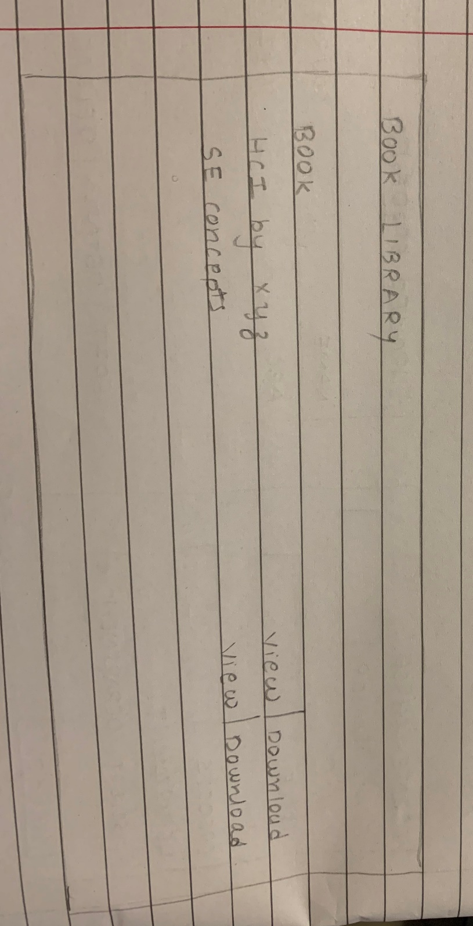

The above figure shows the Book libraby page for students to download study materials.

This image depicts the Assignmnet upload files by the faculty and they can also view the files they uploaded.

This image shows the Home page of the System and college calendar.

**STORY-BOARD PROTOTYPE:**

**2.EVALUATION:**

For the evaluation phase, I have a walkthrough for all tasks that the systems will perform.

|  |  |  |
| --- | --- | --- |
| Description of Step | Does the user have the knowledge/training to do this? | Is it believable that they would do it? Are they motivated? |
| Enrollment into Elective Courses | Yes, the user will be having the knowledge to which course to select from the given options as the details for each subject will be given. | They will use the task as it will give the information for the courses and platform under one page. |
| Enrolled Students | The Faculty can view the students that are registered for the courses. | They will use this module to know the number of students enrolled. |
| Assignment Submission | Its not that they will need to be familiar with the module because its too simple to understand. | Yes, they will use this for their ease. |
| Book Library | No such kind of training will be required as the user will just click download button if he wants that book. | Rather than asking for materials to everyone it is better to get it on your own. |

**3.Choice and Refinement:**

For future development I will use the story-board prototype as it is easy to understand by any user as how to do and what do to will be mentioned in the images.

So, by the help of Story-Board prototyping the user will get ideas for the input and what output they must get.

The tasks that will be affected are view, download and upload for different users.

The prototype was modified in the way that it provides some basic guidelines for the users to interact with the system.

The User base was same for both paper-type protocol and story-board prototyping.

The only changes that are made in the interfaces is the authorities that will be given to the user on basis of their login credentials.

**4.Finalized Design:**

The interaction starts with the user that will log-in to the system. The login step will be simple as the user just needs to enter username and password and if not registered, they can click on the New User and that link will navigate to the registration page.

After that, the user can see the Home Page. The homepage itself will be college calendar page viewing the events happening on campus. By default, it will show the events for the current date and if you want to know upcoming events than the user simply needs to click on the date and the events registered will be shown.

There will be three options available to the users to navigate, Assignment, Library and Enrollment. The user can select that according to the need.

Let’s say they selected Assignment,

Assignment page for Faculty:

If a faculty is the user than they will be having the option to upload any assignment and view the uploaded assignment.

If the user is a Student than they can download the assignment uploaded by the faculty and upload their completed work.

Next up, the Library page:

The faculty can upload any study material that wish to provide the students and the students can have the option to view and download that material.

For the Enrollment page:

The faculty will be creating a course and the details of that course will be also provided by him. The course detail will include the description of the subject, course credits and the name of faculty.

The student can have the authority to select the courses that are being provided by the faculty and the details so that they can choose from the number of courses which will be the most appropriate for them.

**5.Lessons Learned:**

For this project prototype, I learnt different types of paper-prototyping available and for what is used for. I designed the user-interfaces for the system by the help of paper prototyping. I created them in a flow in which my system would perform.

Prototyping any project is crucial as it allows the designers to present the designs and actions performed. We can also know at a very early stage if the designs or protypes is having any errors.